📄 **Tools PoC Report**

**Title:** OSINT-Based Environmental & Humanitarian Awareness Tools

**Intern ID:** 159

**Name: Ishan Chowdhury**

**Tool ID: 43,44**

## Tool Name: ****HungerMap by WFP:-(****https://hungermap.wfp.org/)

### ****History****

The HungerMap is maintained by the **World Food Programme (WFP)** of the United Nations. It was launched to centralize real-time data on food insecurity, conflict zones, weather impacts, and economic conditions that affect hunger worldwide.

### ****Description****

The HungerMap provides a **data-rich dashboard** that helps track food crises, population vulnerability, and regional-level insights using **OSINT** and field data from governments, NGOs, and satellites.

### ****What Is This Tool About?****

HungerMap visualizes **real-time food security levels** using a heatmap interface. It combines multiple indicators like weather shocks, conflicts, market disruptions, and food access to help **track humanitarian crises** and direct aid efforts.

### ****Key Characteristics / Features****

1. Live global food insecurity map
2. Risk classification (Crisis, Emergency, Famine)
3. Multi-dimensional indicators (climate, conflict, economy)
4. Real-time data sync from multiple field sources
5. Country-wise statistics with trend visualizations
6. Interactive filters (location, timeline, risk type)
7. Downloadable datasets for analysis
8. User-friendly web interface
9. Supports multilingual usage
10. Compatible with mobile and desktop browsers

### ****Types / Modules Available****

1. **Global Food Security Map**
2. **Country Dashboard**
3. **Food Prices Tracking Tool**
4. **Trend Analytics**
5. **Crisis Zone Overview**

### ****How Will This Tool Help?****

1. Helps analysts identify **food crisis-prone regions**
2. Provides **OSINT support** to humanitarian cybersecurity reports
3. Assists in disaster recovery and prediction
4. Enables NGO and government teams to prioritize regions needing aid
5. Integrates into **geopolitical risk assessments**
6. Can support red/blue team simulations around crisis or civil unrest

**Proof of Concept (PoC) Images:**

### ****Image 1 – Global Food Insecurity Overview****

This global heatmap visualizes **worldwide hunger hotspots**, with red zones indicating very high prevalence of food insecurity. Over **20 countries** are currently experiencing extreme hunger. Layers highlight hazards, conflicts, vegetation stress, and rainfall anomalies.

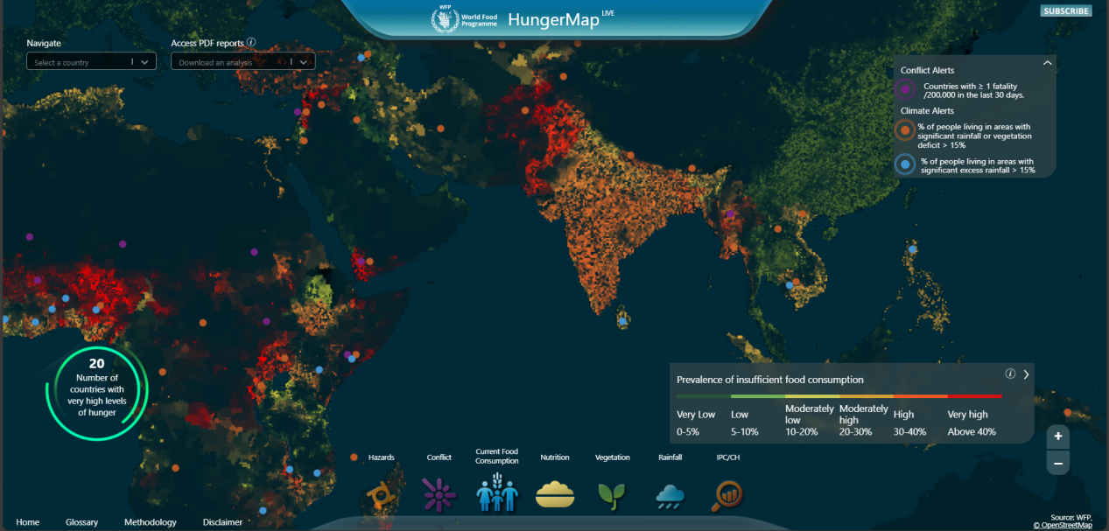

### ****Image 2 – Bhutan Regional Analysis****

Zoomed into **Bhutan**, this map shows district-wise data. The district of **Punakha** has a **30.81% rate** of people facing insufficient food consumption. There is a lack of acute and chronic malnutrition data, highlighting a potential data blind spot.

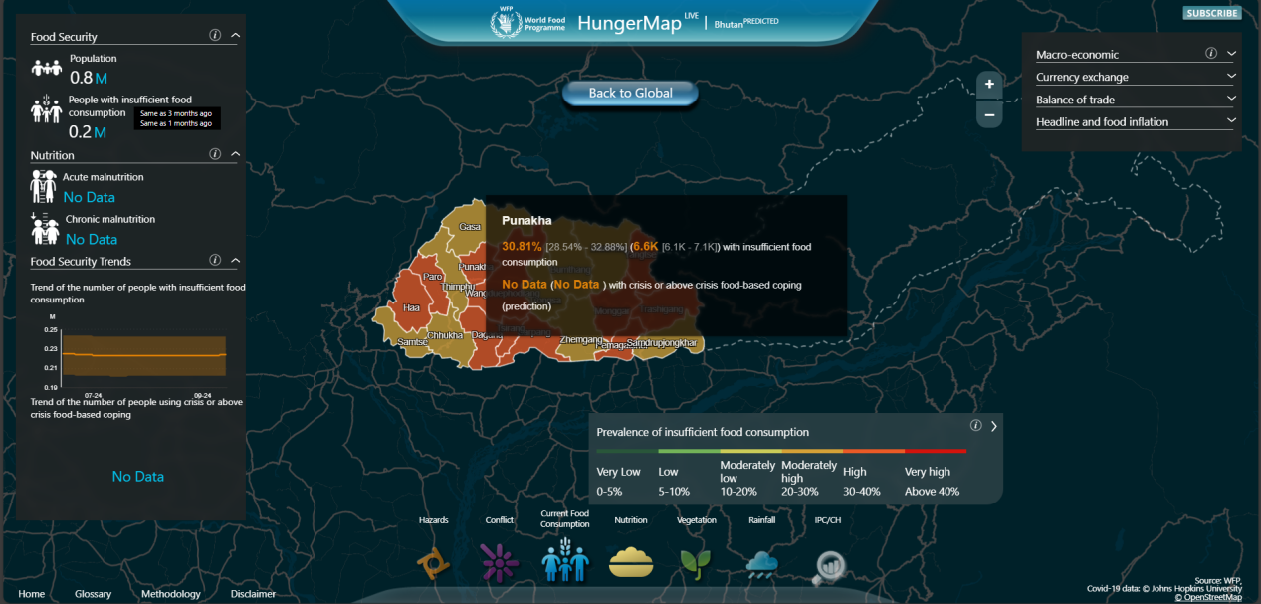

### ****Image 3 – Ukraine (Dnipropetrovska) Crisis Trends****

In **Dnipropetrovska, Ukraine**, 14.66% of people are food insecure. The orange trend lines show a **steady rise in crisis-based coping mechanisms** due to prolonged conflict and economic instability. This kind of live data can assist humanitarian analysts.

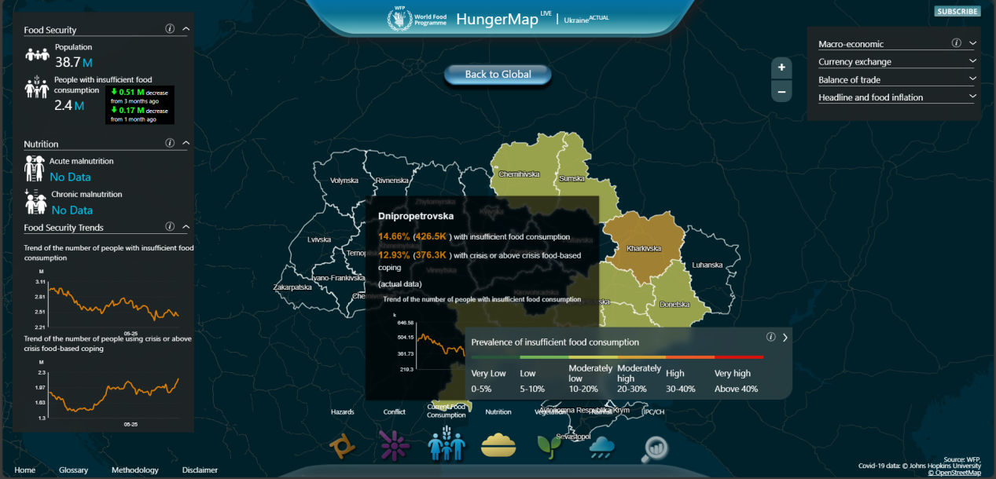

### ****Image 4 – Ukraine (Kharkivska) Deep Dive****

**Kharkivska**, Ukraine is under critical watch, with over **25.86% of its population** relying on crisis or above-level coping strategies. The chart displays live fluctuations in food access based on conflict severity and macroeconomic challenges.

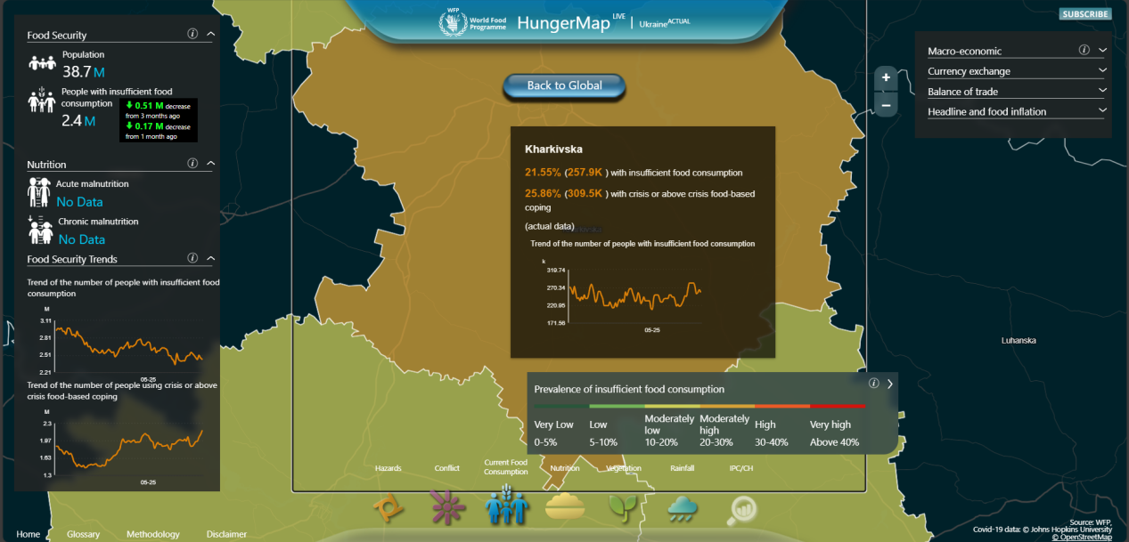

### ****Image 5 – Kenya (North Eastern) Alert****

In **Kenya’s North Eastern region**, **32.65% of people** face food insecurity and **37.41% are in crisis**. This region has seen a sharp upward trend, showing the **impact of climate shocks and internal migration** on local food availability.

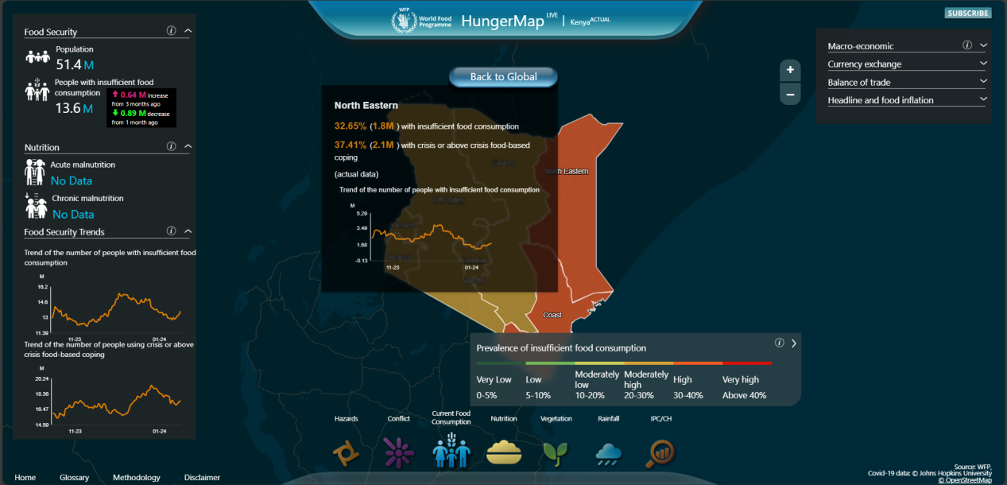

### ****15-Liner Summary – HungerMap by WFP****

1. Provides real-time tracking of global food insecurity

2. Developed and maintained by the UN World Food Programme (WFP)

3. Covers 90+ countries with region-specific hunger data

4. Integrates satellite, field reports, and economic indicators

5. Visualizes conflict zones and climate-driven food shocks

6. A powerful resource for humanitarian and OSINT investigations

7. Allows filtering by geography, timeline, and risk category

8. Offers dynamic graphs and trend analysis for food security

9. Fully mobile-responsive and browser-friendly

10. Enables data exports for further research/reporting

11. Crucial for refugee crisis analysis and response planning

12. Combines macroeconomic, nutrition, and rainfall data

13. Publicly accessible with no login required

14. Actively used in disaster response and crisis monitoring

15 Promotes global awareness through open-source data layers

### ****Time to Use / Best Case Scenarios****

1. In **disaster response** operations
2. During **cyber-humanitarian research**
3. When building **regional threat intel** dashboards
4. For **international NGO briefings**

### ****When to Use During Investigation****

1. While assessing **civil unrest** due to food shortages
2. When monitoring **nation-state exploitation of crisis**
3. In **disaster forecasting** (conflict, flood, drought)
4. During **vulnerability mapping** in red team simulations

### ****Best Person to Use This Tool & Required Skills****

**Best User:** OSINT Analyst / Crisis Researcher / Threat Intel Researcher

**Required Skills:**

1. Data visualization interpretation
2. Geopolitical understanding
3. Use of analytical tools (Excel, Tableau, Kibana, etc.)

### ****Flaws / Suggestions to Improve****

1. No API for automated scraping
2. Lacks historical playback
3. Could benefit from predictive modeling
4. No mobile app version
5. Some regions lack real-time sync

### ****Good About the Tool****

1. Reliable data from WFP
2. Free and open access
3. Rich with layers of context
4. Great for public awareness and policy reports

**Tool Name:** **Rain Alarm:- (**https://www.rain-alarm.com/ **)**

### ****History****

Rain Alarm was created as a **real-time weather radar-based precipitation alert system**. It detects local weather patterns such as rainfall or storms and alerts users instantly. It's popular among travelers, meteorologists, and emergency services.

### ****Description****

Rain Alarm notifies users when **precipitation is detected** near their location. It uses **public radar data**, analyzes it live, and delivers visual alerts through web and app interfaces.

### ****What Is This Tool About?****

It tracks **rain, storms, and snow** and alerts users based on **location-based radar scans**. A great tool for **environmental OSINT** and **safety monitoring**.

### ****Key Characteristics / Features****

1. Real-time rain detection
2. Visual alert map
3. Regional radar overlay
4. Mobile and browser-based support
5. Geofencing options
6. Alert customization
7. Available in multiple languages
8. Lightweight interface
9. No login required
10. Public radar integration

### 🔧 ****Types / Modules Available****

1. **Map Radar View**
2. **Alert Sound Notifications**
3. **Location Tracking**
4. **Radar Intensity Overlays**

### ****How Will This Tool Help?****

1. Predict and track **flood-prone situations**
2. Aid OSINT teams during **natural disaster intel gathering**
3. Enhance **personal and team safety** during field operations
4. Can be integrated into emergency notification protocols

**Proof of Concept (PoC) Images:**

### ****Image 1 – Odisha Region (Rain Radar)****

**🔍 Description**:  
This radar visualization shows rainfall patterns over Odisha, with weather overlays on a live map.

**🛡️ Cybersecurity Risk**:  
If weather API data is transmitted without encryption, attackers could perform **Man-in-the-Middle (MITM)** attacks to manipulate or fake rainfall data, affecting emergency services or public alert.

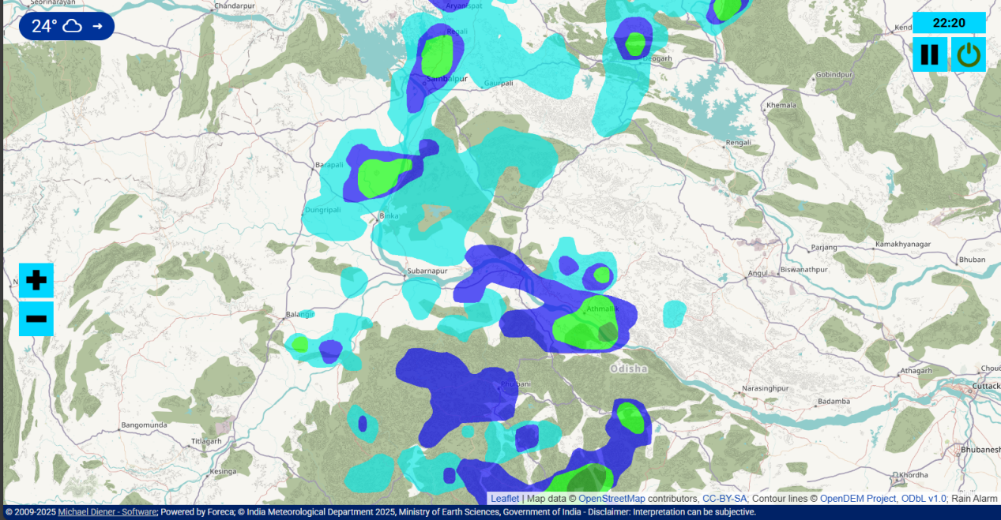

### ****Image 2 – West Bengal/Bangladesh Border****

**🔍 Description**:  
Heavy to moderate rain is visualized using color gradients. This data is critical for flood alerts.

**🛡️ Cybersecurity Risk**:  
If **API endpoints are exposed** or lack proper authentication, unauthorized users might flood the system with fake data or queries, leading to **Denial of Service (DoS)**.

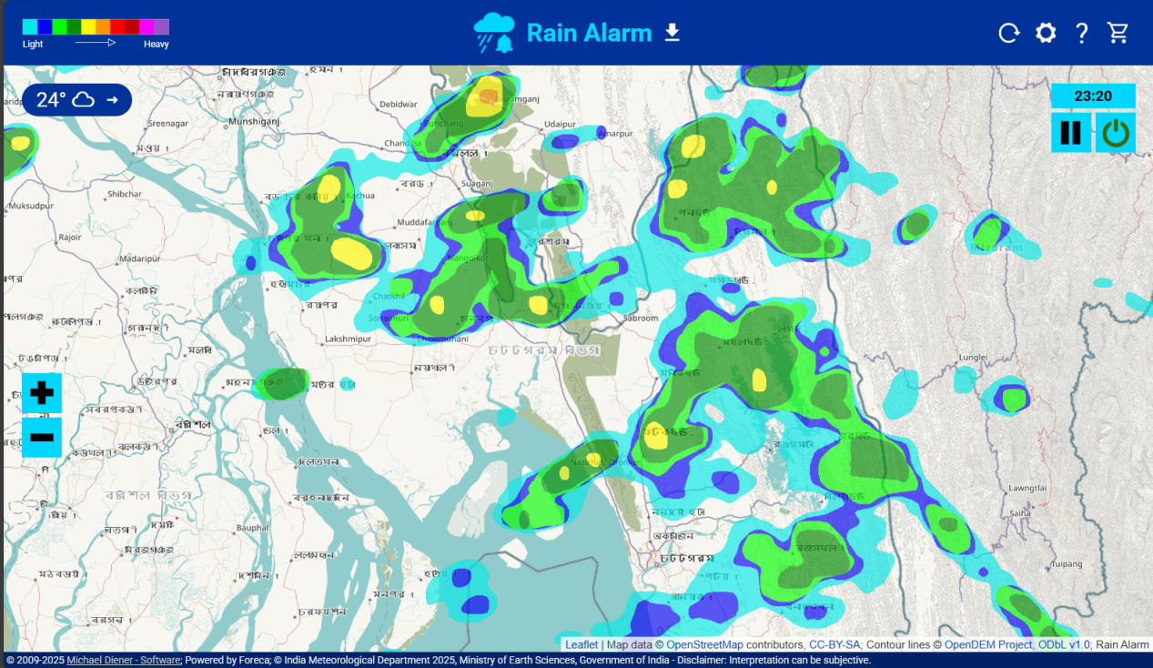

### ****Image 3 – Central Europe (Poland)****

**🔍 Description**:  
Rain radar image of Poland with heavier clusters indicated in red and yellow.

**🛡️ Cybersecurity Risk**:  
An attacker could inject malicious JavaScript through third-party mapping libraries if **Content Security Policy (CSP)** is not enforced, leading to **Cross-Site Scripting (XSS)**.

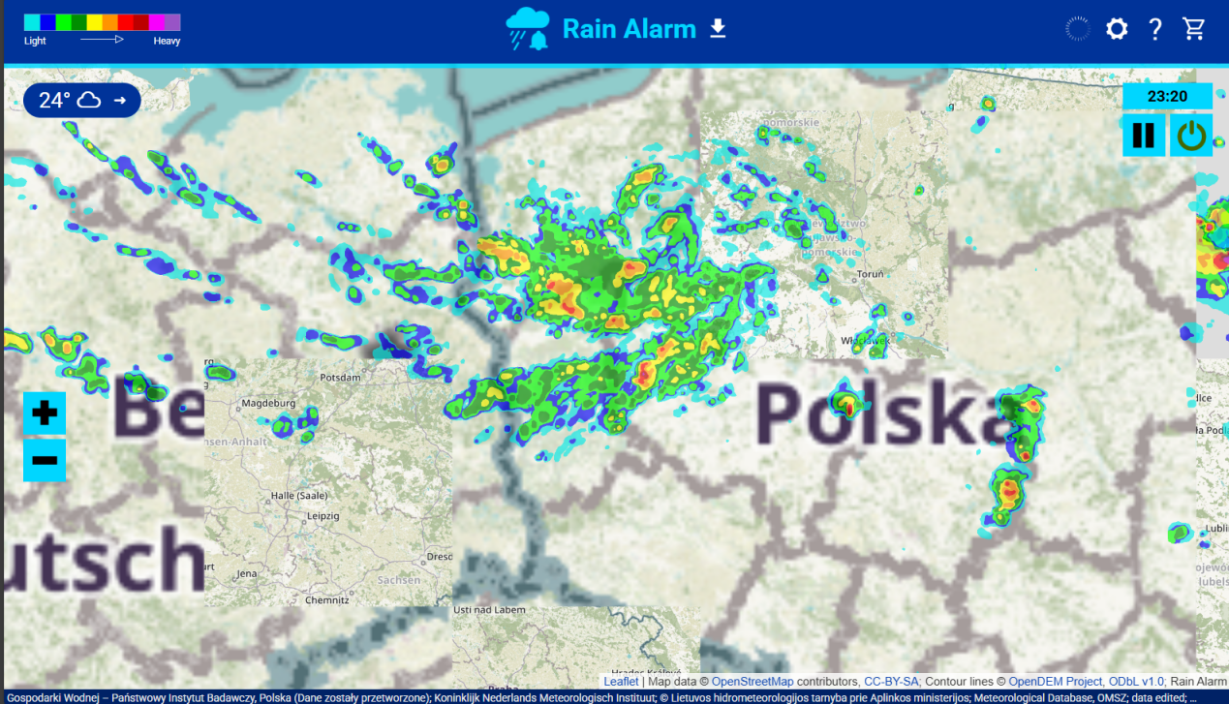

### ****Image 4 – Western Poland/Berlin Region****

**🔍 Description**:  
Radar clusters suggest widespread rainfall across the Berlin region.

**🛡️ Cybersecurity Risk**:  
**Rate-limiting** is essential to prevent abuse. Attackers can repeatedly query the map layer APIs causing **performance degradation or IP bans** from upstream data providers.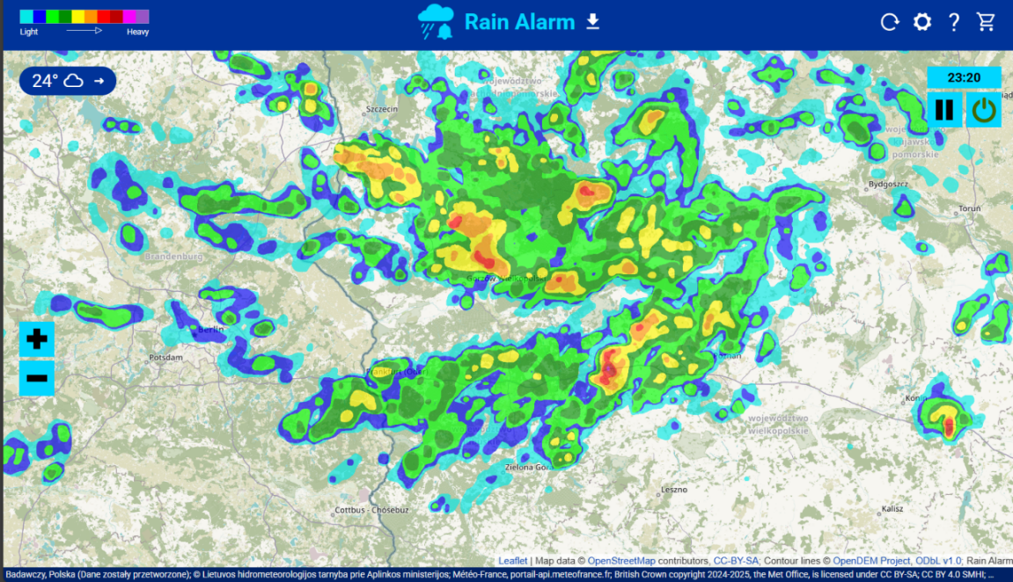

### ****Image 5 – Nagpur/Gadchiroli Region****

**🔍 Description**:  
Radar shows high precipitation in eastern Maharashtra with cloud overlays.

**🛡️ Cybersecurity Risk**:  
Without proper **access control**, sensitive geospatial data could be scraped or cloned by malicious actors, risking **data exfiltration** or **unauthorized duplication**.

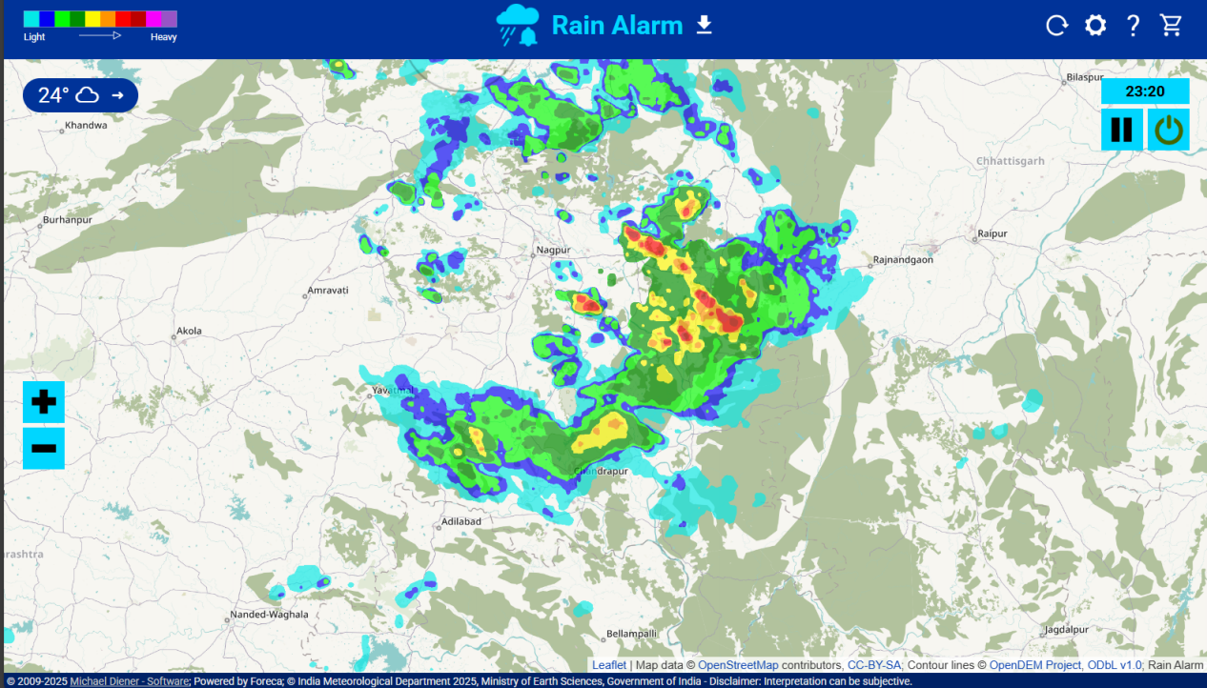

### ****15-Liner Summary****

1. Real-time rain detection

2. Public radar data usage

3. Visual + audio alerts

4. Great for outdoor ops

5. Mobile-friendly

6. Location-based filtering

7. No account needed

8. High accuracy in urban zones

9. Radar overlay intensity

10.Storm tracking supported

11. Good UI

12. Instant response

13. Customizable settings

14. Used in logistics, NGOs

15. Free to use

### ****Time to Use / Best Case Scenarios****

1. During **storm-prone days**
2. For **disaster team briefings**
3. Before launching **outdoor operations**
4. In **event risk planning**

### ****When to Use During Investigation****

1. Before entering an affected flood zone
2. While tracking weather-related outages or damages
3. During **climate impact analysis**
4. In **rescue mission OSINT**

### ****Best Person to Use This Tool & Required Skills****

**Best User:** Crisis Manager / OSINT Analyst / Field Team Lead

**Required Skills:**

1. Basic weather map reading
2. Geolocation understanding
3. Familiarity with radar overlays

### ****Flaws / Suggestions to Improve****

1. Limited in non-radar-covered areas
2. No historical weather logging
3. Could benefit from exportable logs
4. No advanced filters for storm types
5. No embedded analytics

### ****Good About the Tool****

1. Instantly useful in emergencies
2. Clean UI
3. Accurate and fast
4. No setup or registration needed
5. Enhances OSINT context

### ****Personal Reflection****

Working on this project was both intellectually rewarding and technically challenging. As an intern, navigating through real-time global datasets like HungerMap and understanding the depth of humanitarian OSINT analysis required dedicated effort. Interpreting complex metrics such as food insecurity rates, trend graphs, and crisis coping indicators tested my data comprehension skills. Additionally, identifying relevant insights and capturing meaningful visual evidence demanded a lot of precision and time. Despite the steep learning curve, this project enhanced my research capabilities and gave me a deeper appreciation for how open-source tools can support global humanitarian and cybersecurity efforts.